Science Highlight
Academia Sinica, Institute of Astronomy & Astrophysics
Release Time：26 January 2017, 23:00, Taipei, Taiwan

An international team using gravitational lenses reports new findings that support a faster than expected expansion of the universe. Dr. Suyu, the leader of the team, is a Visiting Scholar and former Assistant Research Fellow of ASIAA, who has conducted important parts of this research at ASIAA.
By using galaxies as giant gravitational lenses, an international group of astronomers using the NASA/ESA Hubble Space Telescope have made an independent measurement of how fast the Universe is expanding. The newly measured expansion rate for the local Universe is consistent with earlier findings. These are, however, in intriguing disagreement with measurements of the early Universe. This hints at a fundamental problem at the very heart of our understanding of the cosmos.
The Hubble constant — the rate at which the Universe is expanding — is one of the fundamental quantities describing our Universe. A group of astronomers from the H0LiCOW collaboration, led by Sherry Suyu (associated with the Max Planck Institute for Astrophysics in Germany, the ASIAA in Taiwan and the Technical University of Munich), used the NASA/ESA Hubble Space Telescope and other telescopes [Note 1] in space and on the ground to observe five galaxies in order to arrive at an independent measurement of the Hubble constant [Note 2].
The new measurement is completely independent of — but in excellent agreement with — other measurements of the Hubble constant in the local Universe that used Cepheid variable stars and supernovae as points of reference (heic1611).
However, the value measured by Suyu and her team, as well as those measured using Cepheids and supernovae, are different from the measurement made by the ESA Planck satellite. But there is an important distinction — Planck measured the Hubble constant for the early Universe by observing the cosmic microwave background.
While the value for the Hubble constant determined by Planck fits with our current understanding of the cosmos, the values obtained by the different groups of astronomers for the local Universe are in disagreement with our accepted theoretical model of the Universe. “The expansion rate of the Universe is now starting to be measured in different ways with such high precision that actual discrepancies may possibly point towards new physics beyond our current knowledge of the Universe,” elaborates Suyu.
The targets of the study were massive galaxies positioned between Earth and very distant quasars — incredibly luminous galaxy cores. The light from the more distant quasars is bent around the huge masses of the galaxies as a result of strong gravitational lensing [Note 3]. This creates multiple images of the background quasar, some smeared into extended arcs.
Because galaxies do not create perfectly spherical distortions in the fabric of space and the lensing galaxies and quasars are not perfectly aligned, the light from the different images of the background quasar follows paths which have slightly different lengths. Since the brightness of quasars changes over time, astronomers can see the different images flicker at different times, the delays between them depending on the lengths of the paths the light has taken. These delays are directly related to the value of the Hubble constant. “Our method is the most simple and direct way to measure the Hubble constant as it only uses geometry and General Relativity, no other assumptions,” explains co-lead Frédéric Courbin from EPFL, Switzerland
Using the accurate measurements of the time delays between the multiple images, as well as computer models, has allowed the team to determine the Hubble constant to an impressively high precision: 3.8% [Note 4] “An accurate measurement of the Hubble constant is one of the most sought-after prizes in cosmological research today,” highlights team member Vivien Bonvin, from EPFL, Switzerland. And Suyu adds: “The Hubble constant is crucial for modern astronomy as it can help to confirm or refute whether our picture of the Universe — composed of dark energy, dark matter and normal matter — is actually correct, or if we are missing something fundamental.”

Notes
- The study used, alongside the NASA/ESA Hubble Space Telescope, the Keck Telescope, ESO’s Very Large Telescope, the Subaru Telescope, the Gemini Telescope, the Victor M. Blanco Telescope, the Canada-France-Hawaii telescope (where ASIAA’s instrumentation contribution include WIRCam and SPIROU), and the NASA Spitzer Space Telescope. In addition, data from the Swiss 1.2-metre Leonhard Euler Telescope and the MPG/ESO 2.2-metre telescope were used.
- The gravitational lensing time-delay method that the astronomers used here to achieve a value for the Hubble constant is especially important owing to its near-independence of the three components our Universe consists of: normal matter, dark matter and dark energy. Though not completely separate, the method is only weakly dependent on these.
- Gravitational lensing was first predicted by Albert Einstein more than a century ago. All matter in the Universe warps the space around itself, with larger masses producing a more pronounced effect. Around very massive objects, such as galaxies, light that passes close by follows this warped space, appearing to bend away from its original path by a clearly visible amount. This is known as strong gravitational lensing.
- The H0LiCOW team determined a value for the Hubble constant of 71.9±2.7 kilometres per second per Megaparsec. In 2016 scientists using Hubble measured a value of 73.24±1.74 kilometres per second per Megaparsec. In 2015, the ESA Planck Satellite measured the constant with the highest precision so far and obtained a value of 66.93±0.62 kilometres per second per Megaparsec.

More information
The Hubble Space Telescope is a project of international cooperation between ESA and NASA.
This research was presented in a series of papers to appear in the Monthly Notices of the Royal Astronomical Society.
The papers are entitled as follows: "H0LiCOW I. H0 Lenses in COSMOGRAIL’s Wellspring: Program Overview", by Suyu et al., "H0LiCOW II. Spectroscopic survey and galaxy-group identification of the strong gravitational lens system HE 0435−1223", by Sluse et al., "H0LiCOW III. Quantifying the effect of mass along the line of sight to the gravitational lens HE 0435−1223 through weighted galaxy counts", by Rusu et al., "H0LiCOW IV. Lens mass model of HE 0435−1223 and blind measurement of its time-delay distance for cosmology", by Wong et al., and "H0LiCOW V. New COSMOGRAIL time delays of HE 0435−1223: H0 to 3.8% precision from strong lensing in a flat ΛCDM model", by Bonvin et al.
The international team consists of: S. H. Suyu (Max Planck Institute for Astrophysics, Germany; Academia Sinica Institute of Astronomy and Astrophysics, Taiwan; Technical University of Munich, Germany), V. Bonvin (Laboratory of Astrophysics, EPFL, Switzerland), F. Courbin (Laboratory of Astrophysics, EPFL, Switzerland), C. D. Fassnacht (University of California, Davis, USA), C. E. Rusu (University of California, Davis, USA), D. Sluse (STAR Institute, Belgium), T. Treu (University of California, Los Angeles, USA), K. C. Wong (National Astronomical Observatory of Japan, Japan; Academia Sinica Institute of Astronomy and Astrophysics, Taiwan), M. W. Auger (University of Cambridge, UK), X. Ding (University of California, Los Angeles, USA; Beijing Normal University, China), S. Hilbert (Exzellenzcluster Universe, Germany; Ludwig-Maximilians-Universität, Munich, Germany), P. J. Marshall (Stanford University, USA), N. Rumbaugh (University of California, Davis, USA), A. Sonnenfeld (Kavli IPMU, the University of Tokyo, Japan; University of California, Los Angeles, USA; University of California, Santa Barbara, USA), M. Tewes (Argelander-Institut für Astronomie, Germany), O. Tihhonova (Laboratory of Astrophysics, EPFL, Switzerland), A. Agnello (ESO, Garching, Germany), R. D. Blandford (Stanford University, USA), G. C.-F. Chen (University of California, Davis, USA; Academia Sinica Institute of Astronomy and Astrophysics, Taiwan), T. Collett (University of Portsmouth, UK), L. V. E. Koopmans (University of Groningen, The Netherlands), K. Liao (University of California, Los Angeles, USA), G. Meylan (Laboratory of Astrophysics, EPFL, Switzerland), C. Spiniello (INAF – Osservatorio Astronomico di Capodimonte, Italy; Max Planck Institute for Astrophysics, Garching, Germany) and A. Yıldırım (Max Planck Institute for Astrophysics, Garching, Germany)
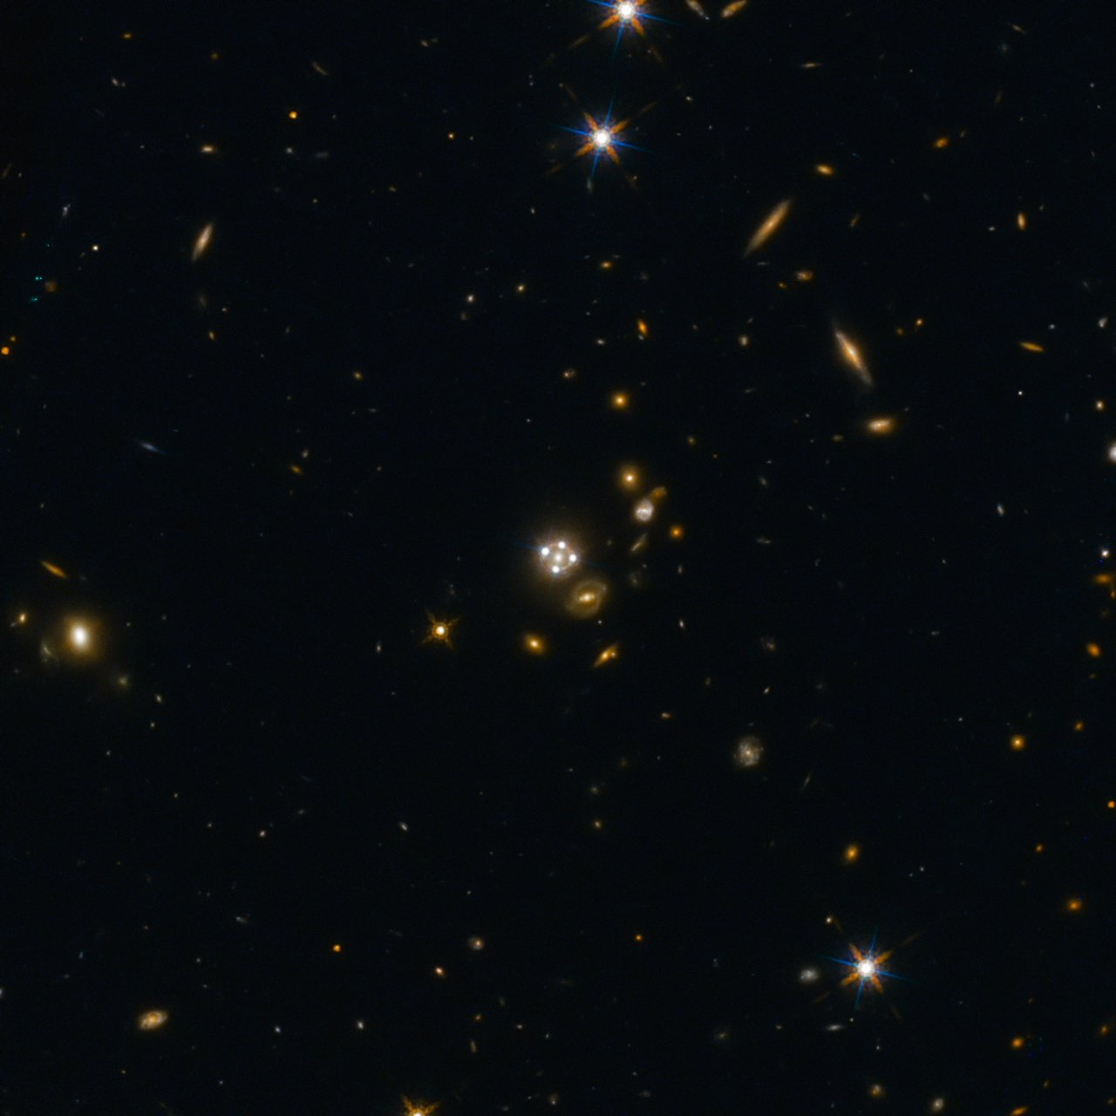
Lensed quasar and its surroundings
HE0435-1223, located in the centre of this wide-field image, is among the five best lensed quasars discovered to date. The foreground galaxy creates four almost evenly distributed images of the distant quasar around it. Credit: ESA/Hubble, NASA, Suyu et al.

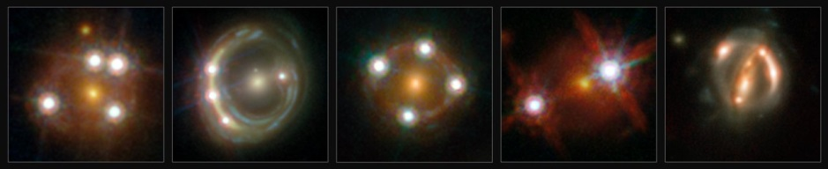
Studied lensed quasars of H0LiCOW collaboration
This montage shows the five lensed quasars and the foreground galaxies studied by the H0LICOW collaboration. Using these objects astronomers were able to make an independent measurement of the Hubble constant. They calculated that the Universe is actually expanding faster than expected on the basis of our cosmological model.
Credit: ESA/Hubble, NASA, Suyu et al.

Links
- Hubblecast 70: Peering around cosmic corners
- H0LiCOW video on recent results
- Link to science paper 1
- Link to science paper 2
- Link to science paper 3
- Link to science paper 4
- Link to science paper 5
- H0LiCOW cooperation

Contact
Sherry Suyu
Max Planck Institute for Astrophysics
Garching, Germany
Tel: +49 89 30000 2015
Email: suyu@mpa-garching.mpg.de

