The onset of an extra-solar system –
feeding a baby star with a dusty hamburger

Accepted by Science Advances, to be published on April 19, 2017.

An international research team, led by Chin-Fei Lee in Academia Sinica Institute of Astronomy and Astrophysics (ASIAA, Taiwan), has made a new high-fidelity image with the Atacama Large Millimeter/submillimeter Array (ALMA), catching a protostar (baby star) being fed with a dusty “Hamburger”, which is a dusty accretion disk. This new image not only confirms the formation of an accretion disk around a very young protostar, but also reveals the vertical structure of the disk for the first time in the earliest phase of star formation. It not only poses a big challenge on some current theories of disk formation, but also potentially brings us key insights on the processes of grain growth and settling that are important to planet formation.

Excitements:

“It is so amazing to see such a detailed structure of a very young accretion disk. For many years, astronomers have been searching for accretion disks in the earliest phase of star formation, in order to determine their structure, how they are formed, and how the accretion process takes place. Now using the ALMA with its full power of resolution, we not only detect an accretion disk but also resolve it, especially its vertical structure, in great detail”, says Chin-Fei Lee at ASIAA.

“In the earliest phase of star formation, there are theoretical difficulties in producing such a disk, because magnetic fields can slow down the rotation of collapsing material, preventing such a disk from forming around a very young protostar. This new finding implies that the retarding effect of magnetic fields in disk formation may not be as efficient as we thought before,” says Zhi-Yun Li at University of Virginia

Properties of the Target Source and ALMA Observational Results:

HH 212 is a nearby protostellar system in Orion at a distance of about 1300 ly. The central protostar is very young with an age of only ~40,000 yrs (which is about 10 millionth of the age of Our Sun) and a mass of ~0.2 Msun. It drives a powerful bipolar jet and thus must accrete material efficiently. Previous search at a resolution of 200 AU only found a flattened envelope spiraling toward the center and a hint of a small dusty disk near the protostar. Now with ALMA at a resolution of 8 AU, which is 25 times higher, we not only detect but also spatially resolve the dusty disk at submillimeter wavelength.

The disk is nearly edge-on and has a radius of about 60 AU. Interestingly, it shows a prominent equatorial dark lane sandwiched between two brighter features, due to relatively low temperature and high optical depth near the disk midplane. For the first time, this dark lane is seen at submillimeter wavelength, producing a “hamburger”-shaped appearance that is reminiscent of the scattered-light image of an edge-on disk in optical and near infrared. The structure of the dark lane clearly implies that the disk is flared, as expected in an accretion disk model.

Future Prospects:

Our observations open up an exciting possibility of directly detecting and characterizing small disks around the youngest protostars through high-resolution imaging with ALMA, which provides strong constraints on theories of disk formation. Our observations of the vertical structure can also yield key insights on the processes of grain growth and settling that are important to planet formation in the earliest phase.
Additional information:
This research was presented in a paper “First Detection of Equatorial Dark Dust Lane in a Protostellar Disk at Submillimeter Wavelength,” by Lee et al. to appear in the journal Science Advances.
The team is composed of Chin-Fei Lee (ASIAA, Taiwan; National Taiwan University, Taiwan), Zhi-Yun Li (University of Virginia, USA), Paul T.P. Ho (ASIAA, Taiwan; East Asia Observatory), Naomi Hirano (ASIAA, Taiwan), Qizhou Zhang (Harvard-Smithsonian Center for Astrophysics, USA), and Hsien Shang (ASIAA, Taiwan).
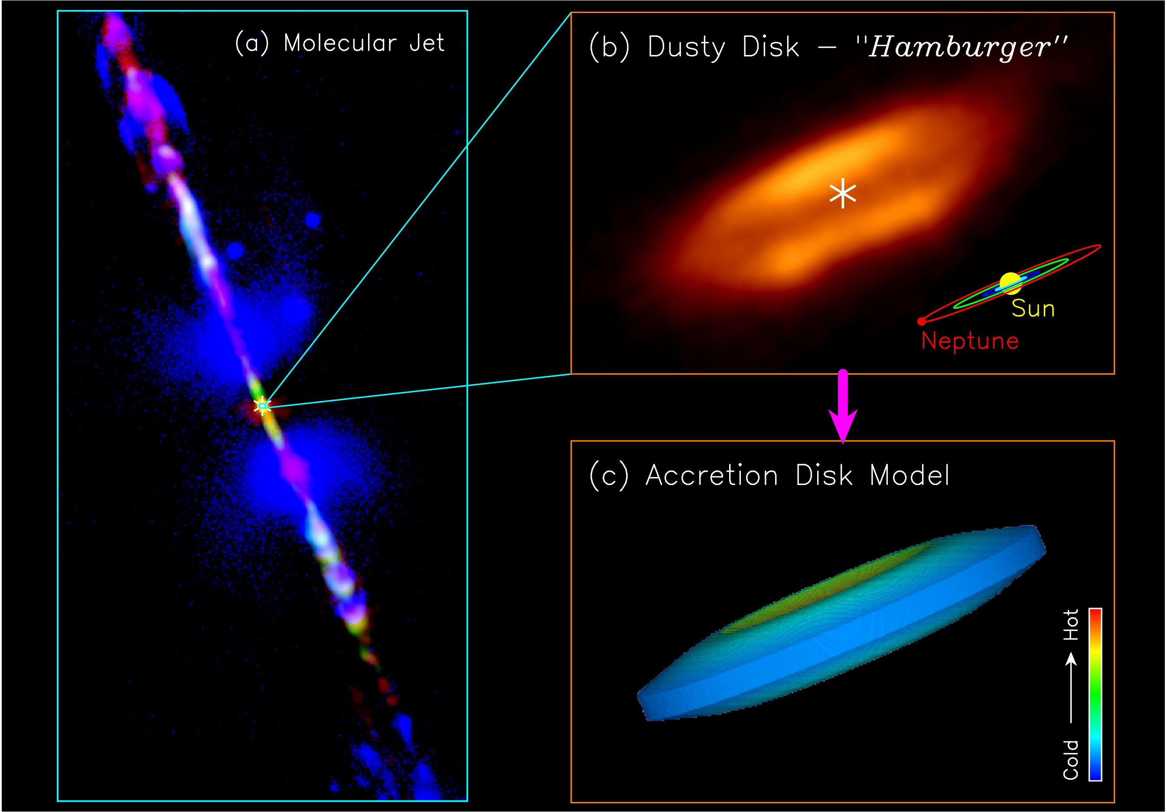
Figure 1: Jet and disk in the HH 212 protostellar system: (a) A composite image for the jet in different molecules, produced by combining the images from the Very Large Telescope (McCaughrean et al. 2002) and ALMA (Lee et al. 2015). Orange image around the center shows the dusty envelope+disk at submillimeter wavelength obtained with ALMA at 200 AU resolution. (b) A zoom-in to the very center for the dusty disk at 8 AU resolution. Asterisks mark the possible position of the central protostar. A dark lane is seen in the equator, causing the disk to appear as a “hamburger”. A size scale of our solar system is shown in the lower right corner for size comparison. (c) An accretion disk model that can reproduce the observed dust emission in the disk.
Credit: ALMA (ESO/NAOJ/NRAO)/Lee et al.

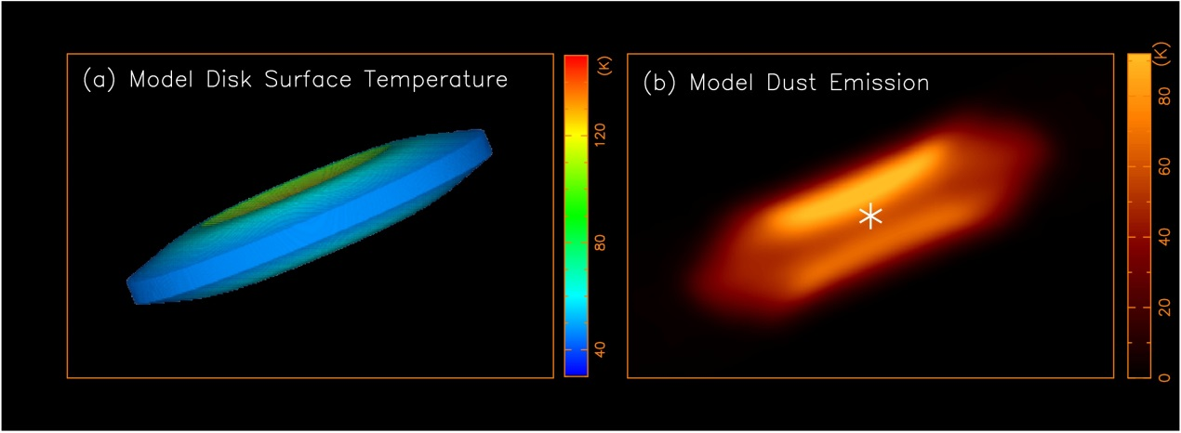
Figure 2: An accretion disk model that can reproduce the observed disk emission. (a) The accretion disk model with the disk surface temperature. (b) The model dust emission map derived from the disk model. This model map is roughly the same as the observed map of the disk.
Credit: Lee et al.

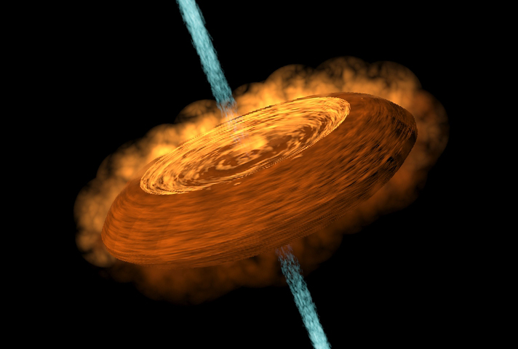
Figure 3: A cartoon showing an accretion disk feeding the central protostar and a jet coming out from the protostar.
Credit: Yin-Chih Tsai/ASIAA

Media contacts:
Dr. Chin-Fei Lee, Institute of Astrophysics and Astronomy, Academia Sinica cflee@asiaa.sinica.edu.tw (Tel) +886-2-2366-5445

Dr. Mei-Yin Chou, Institute of Astrophysics and Astronomy, Academia Sinica cmy@asiaa.sinica.edu.tw (Tel) +886-2-2366-5415

