Baby Star Spits a “Spinning Jet” As It Munches Down on a “Space Hamburger”

Accepted by Nature Astronomy, to be published in June 2017.

Protostellar jets are seen coming out from protostars (baby stars), representing one of the most intriguing signposts of star formation. An international research team, led by Chin-Fei Lee in Academia Sinica Institute of Astronomy and Astrophysics (ASIAA, Taiwan), has made a new breakthrough observation with the Atacama Large Millimeter/submillimeter Array (ALMA), finding a protostellar jet to be spinning, convincingly for the first time. This new result confirms the expected role of the jet in removing the excess angular momentum from the innermost region of an accretion disk (space hamburger), providing a solution to the long-standing problem of how the inner accretion disk can actually feed a protostar.

Excitements:

“We see jets coming out from most of baby stars, like a train of bullets speeding down along the rotational axis of the accretion disks. We always wonder what their role is. Are they spinning, as expected in current models of jet launching? However, since the jets are very narrow and their spinning motion is very small, we had not been able to confirm their spinning motion. Now using the ALMA with its unprecedented combination of spatial and velocity resolutions, we not only resolve a jet near a protostar down to 10 AU but also detect its spinning motion”, says Chin-Fei Lee at ASIAA. “It looks like a baby star spits a spinning bullet each time it takes a bite of a space hamburger.”

“The central problem in forming a star is the angular momentum in the accretion disk which prevents material from falling into the central protostar. Now with the jet carrying away the excess angular momentum from the material in the innermost region of the disk, the material can readily fall into the central protostar from the disk”, says Paul Ho at ASIAA.

Properties of the Target Source and ALMA Observational Results:

HH 212 is a nearby protostellar system in Orion at a distance of about 1300 ly. The central protostar is very young with an age of only 40,000 yrs (which is about 10 millionth of the age of Our Sun) and a mass of only 0.2 Msun. Recent ALMA observations at submillimeter wavelength have detected an accretion disk feeding the central protostar. The disk is nearly edge-on and has a radius of about 60 AU. Interestingly, it shows a prominent equatorial dark lane sandwiched between two brighter features, appearing as a “space hamburger”.

The central protostar drives a powerful bipolar jet. Previous observations at a spatial resolution of 140 AU could not confirm a rotation for the jet. Now with ALMA at a resolution of 8 AU, which is about 17 times higher, we zoom in to the innermost part of the jet down to within 10 AU of the central protostar and find a jet rotation. The angular momentum is so small that the jet has to be launched from the innermost region of the disk at about 0.05 AU from the central protostar, well consistent with current models of the jet launching.

This new finding indicates that the jet indeed carries away part of the angular momentum (rotational momentum) from the material in the innermost region of the accretion disk (space hamburger), which is rotating around the central protostar. This reduces the rotation of the material there, allowing the disk to feed the central protostar.

Future Prospects:

Our observations open up an exciting possibility of detecting and measuring jet rotation around the protostars through high-resolution imaging with ALMA, which provides strong constraints on theories of jet formation in star formation. In addition, our observations also open up the possibility of detecting jet rotation in other kind of objects, e.g., active nuclei of galaxies, which may play the same role of extracting disk angular momentum as the protostellar jets.
Additional information:
This research was presented in a paper “A Rotating Protostellar Jet Launched from the Innermost Disk of HH 212,” by Lee et al. to appear in the journal Nature Astronomy.
The team is composed of Chin-Fei Lee (ASIAA, Taiwan; National Taiwan University, Taiwan), Paul T.P. Ho (ASIAA, Taiwan; East Asia Observatory), Zhi-Yun Li (University of Virginia, USA), Naomi Hirano (ASIAA, Taiwan), Qizhou Zhang (Harvard-Smithsonian Center for Astrophysics, USA), and Hsien Shang (ASIAA, Taiwan).
Media contacts:
Dr. Chin-Fei Lee, Institute of Astrophysics and Astronomy, Academia Sinica cflee@asiaa.sinica.edu.tw (Tel) +886-2-2366-5445
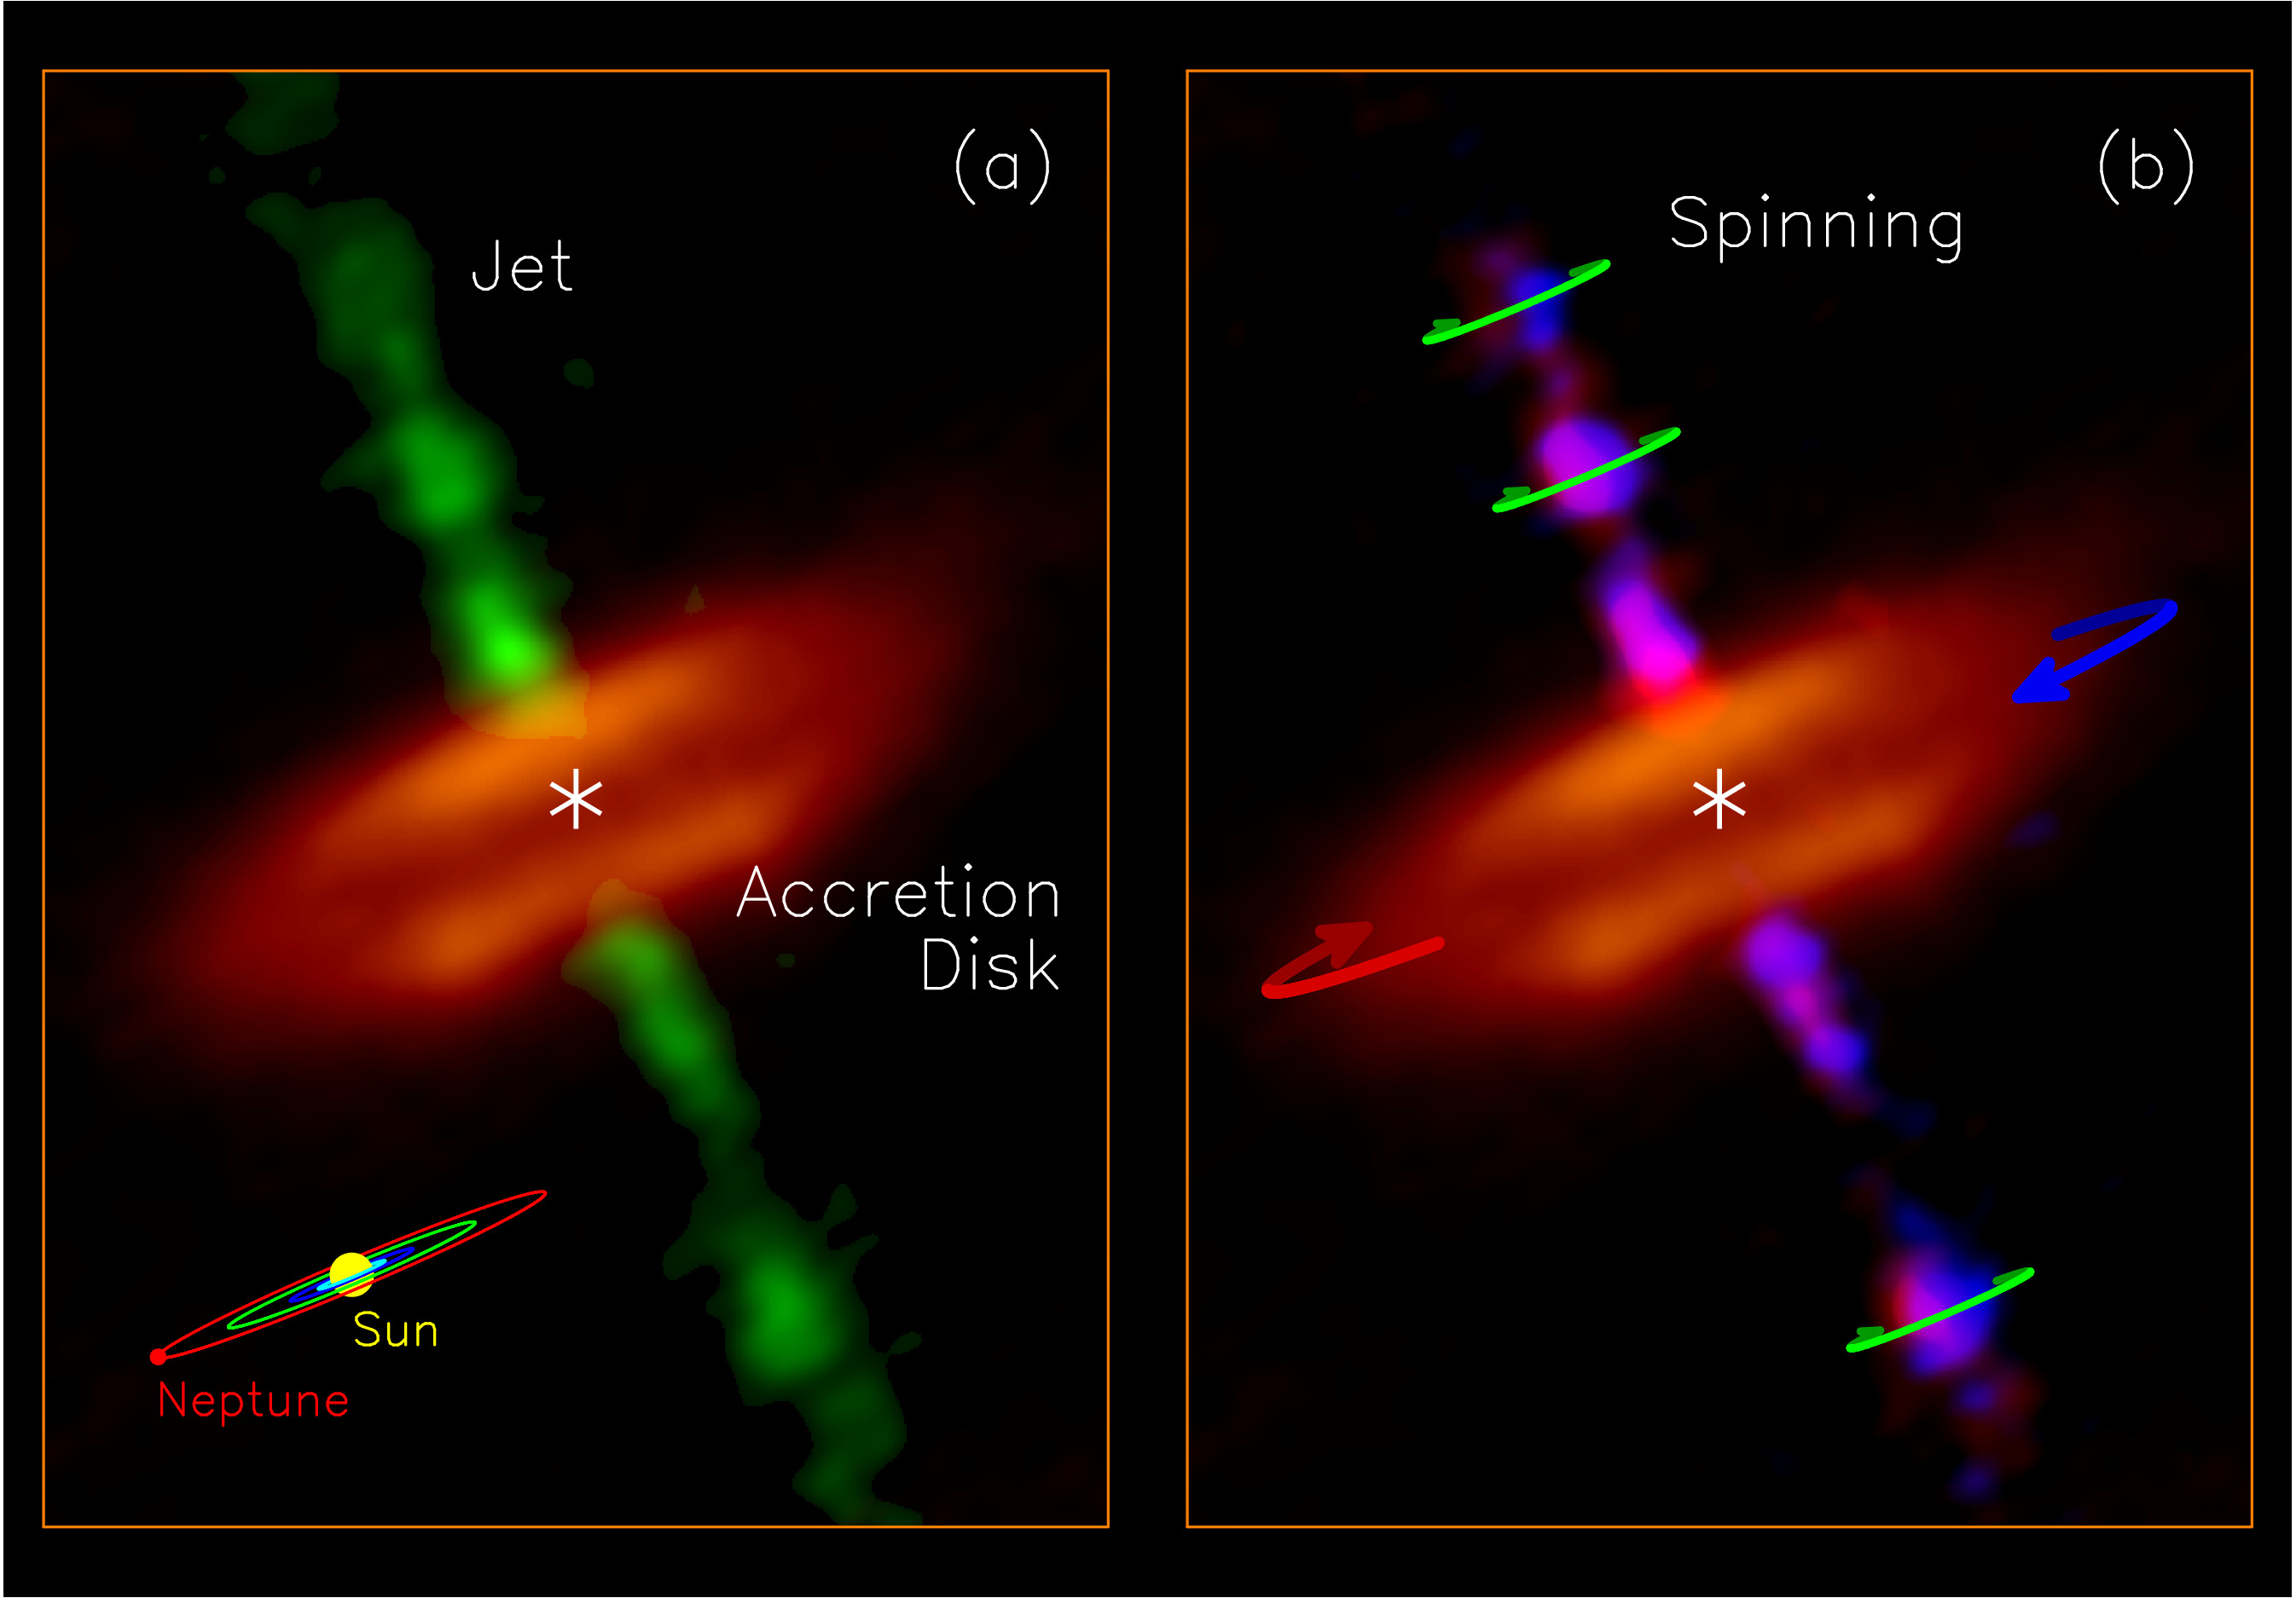
Figure 1: Jet and disk in the HH 212 protostellar system: (a) Molecular jet (green image) ejected from the innermost part of the accretion disk (orange image), observed with ALMA at a resolution of 8 AU. A dark lane is seen in the disk equator, causing the disk to appear as a “hamburger”. A size scale of our solar system is shown in the lower right corner for size comparison. (b) Split of the redshifted (turning away from us) and blueshifted (turning toward us) emission of the jet in order to show the spinning motion of the jet, as indicated by the green arrows. Blue and red arrows show the rotation of the disk, which has a direction the same as the jet rotation. Credit: ALMA (ESO/NAOJ/NRAO)/Lee et al.

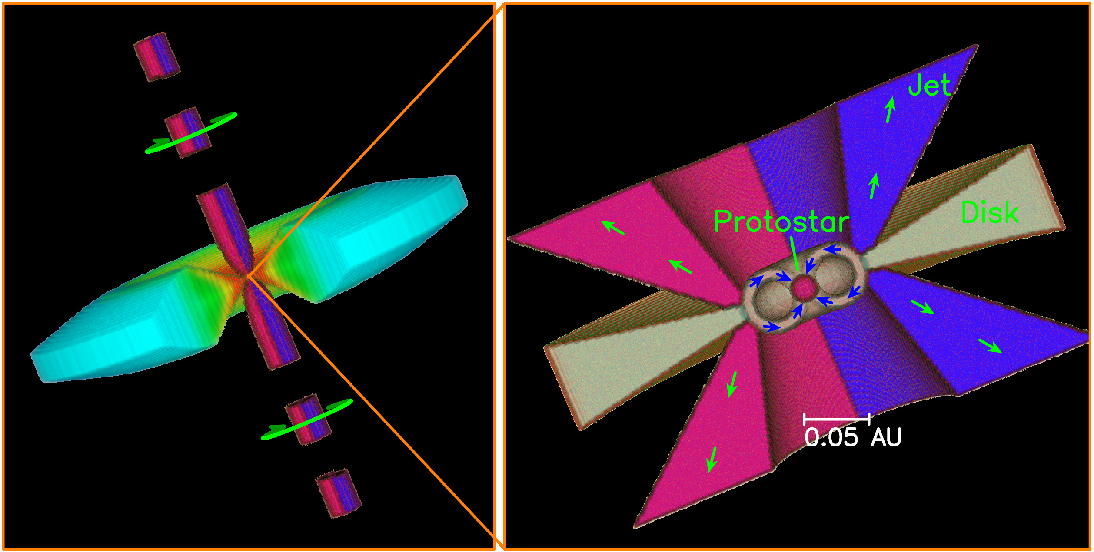
Figure 2: A 3D cartoon showing a spinning jet coming out from an accretion disk that feeds the central protostar. (Left) The jet is spinning (as shown by the green arrows), with the blue part turning toward us and the red part turning away from us. In the disk, the blue color is cooler than the orange color. (Right) A zoom-in to the innermost region, showing the possible disk accretion and jet launching processes near the protostar. Our results imply that the jet is launched at about 0.05 AU, as shown by the green arrows. The jet carries away the excess angular momentum, allowing the disk material there to fall into the central protostar, as shown by the blue arrows. As in current jet models, the jet is hollow and higher resolution is needed to check it. Credit: Lee, C.-F.

