Beer On Space Hamburger around a Baby Star

Accepted by Astrophysical Journal, to be published in May 2019.

An international research team, led by Chin-Fei Lee in Academia Sinica Institute of Astronomy and Astrophysics (ASIAA, Taiwan), has detected beer (ethanol) on a space hamburger (accretion disk) around a protostar (baby star), with the Atacama Large Millimeter/submillimeter Array (ALMA). Besides, the team has also detected other organic molecules including ketene, formic acid, deuterated acetonitrile, and methyl formate. These molecules play a crucial role in producing the rich organic chemistry needed for life and could help us understand how life came to be on Earth.

Excitements:

“Space hamburger (accretion disk) in the HH 212 star-forming system is rich in organic molecules. Soon after it was discovered two years ago, a few organic molecules were detected on its surface (atmosphere). Methanol was one of them. Thus, we wondered if ethanol, which is a drinkable alcohol and sometimes called grain alcohol, could also be detected. Now using the ALMA with its unprecedented combination of spatial resolution and sensitivity, we have detected more organic molecules including ethanol (see Figure 1) and methyl formate”, says Chin-Fei Lee at ASIAA with excitement. “Interestingly, the alcohol degree (by mass) was estimated to be greater than about 2.8% and thus could be similar to that of a regular beer.”

These molecules might have formed on icy grains in the disk and then be released in to gas phase by the heat at about 150 K. One of the next molecules to search in the disk is glycolaldehyde. It is a simple form of sugar that can form ribose, which is a major component of RNA. We have detected its isomer methyl formate and expect to detect it with deeper ALMA observations. These molecules can be incorporated into the new planets to be formed in the disk.

Properties of the Target Source:

HH 212 is a nearby protostellar system in Orion at a distance of about 1300 ly. The central protostar is very young with an age of only 40,000 yrs (which is about 10 millionth of the age of Our Sun) and a mass of only 0.2 Msun. An accretion disk (with a size similar to our solar system) is seen feeding the protostar actively. The disk is nearly edge-on and has a radius of about 60 AU. Interestingly, it shows a prominent equatorial dark lane sandwiched between two brighter features, appearing as a “space hamburger” (see Figure 1).

Future Prospects:

The team’s observations open up an exciting possibility of detecting complex organic molecules in the disk around baby stars through high-resolution and high-sensitivity imaging with ALMA, which provides strong constraints on theories of their formation in star and planet formation. In addition, the observations also open up the possibility of detecting more complex organic molecules and biomolecules that shed light on the origin of life.
Additional information:
This research was presented in a paper “First Abundance Measurement of Organic Molecules in the Atmosphere of the HH 212 Protostellar Disk,” by Lee et al. to appear in the Astrophysical Journal.
The team is composed of Chin-Fei Lee (ASIAA, Taiwan; National Taiwan University, Taiwan), Claudio Codella (INAF, Italy; University Grenoble Alpes, CNAS, France) Zhi-Yun Li (University of Virginia, USA), and Sheng-Yuan Liu (ASIAA, Taiwan).
Media contacts:
Dr. Chin-Fei Lee, Institute of Astrophysics and Astronomy, Academia Sinica cflee@asiaa.sinica.edu.tw (Tel) +886-2-2366-5445

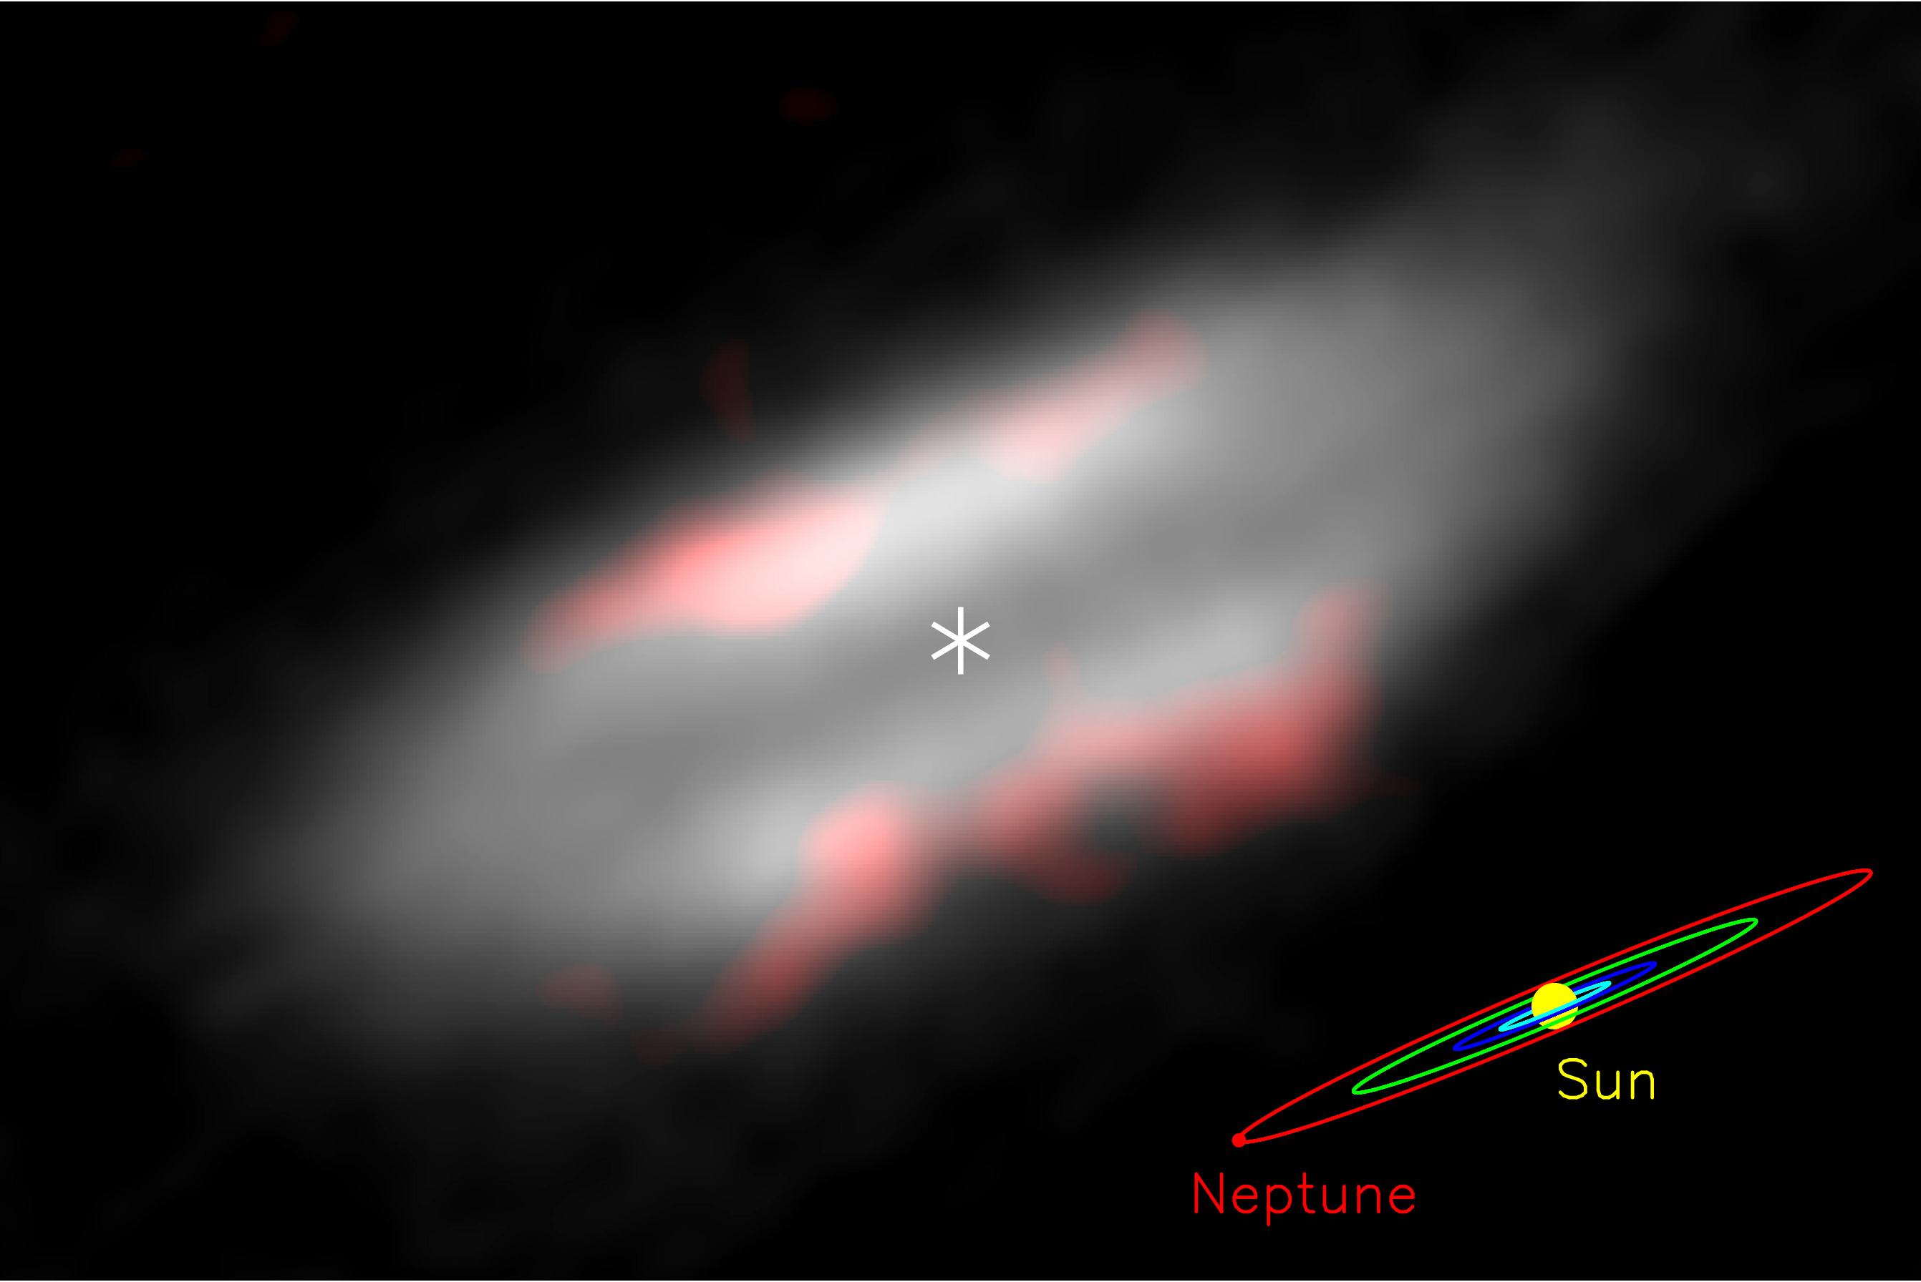
Figure 1: Accretion disk (space hamburger) and ethanol in the HH 212 star-forming system. Gray image shows the accretion disk feeding the central protostar (marked with an asterisk) and orange image shows the distribution of ethanol on the surface (atmosphere) of the disk. Credit: ALMA (ESO/NAOJ/NRAO)/Lee et al.
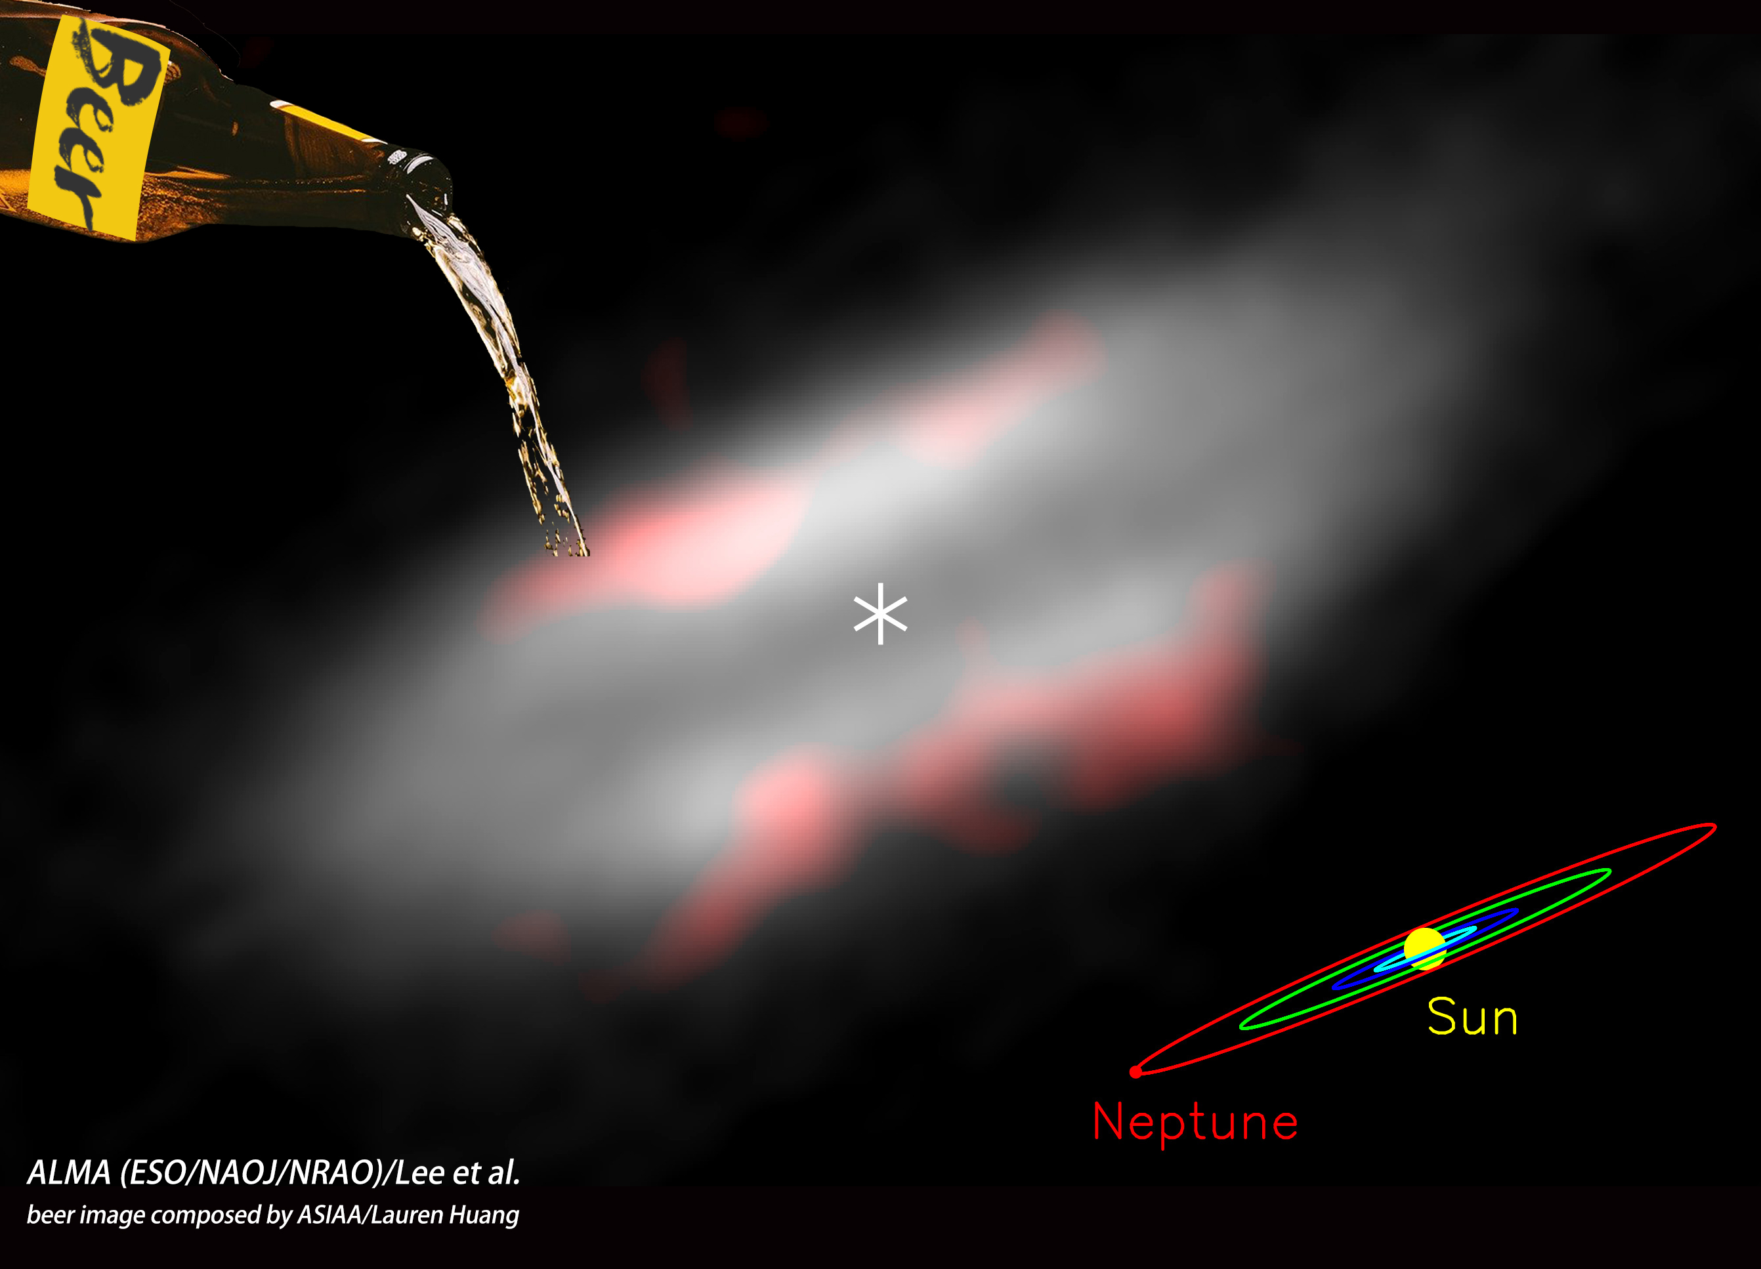
Figure 2: Beer on the space hamburger?

