New Images of M87*: Proof of a Persistent Black Hole Shadow

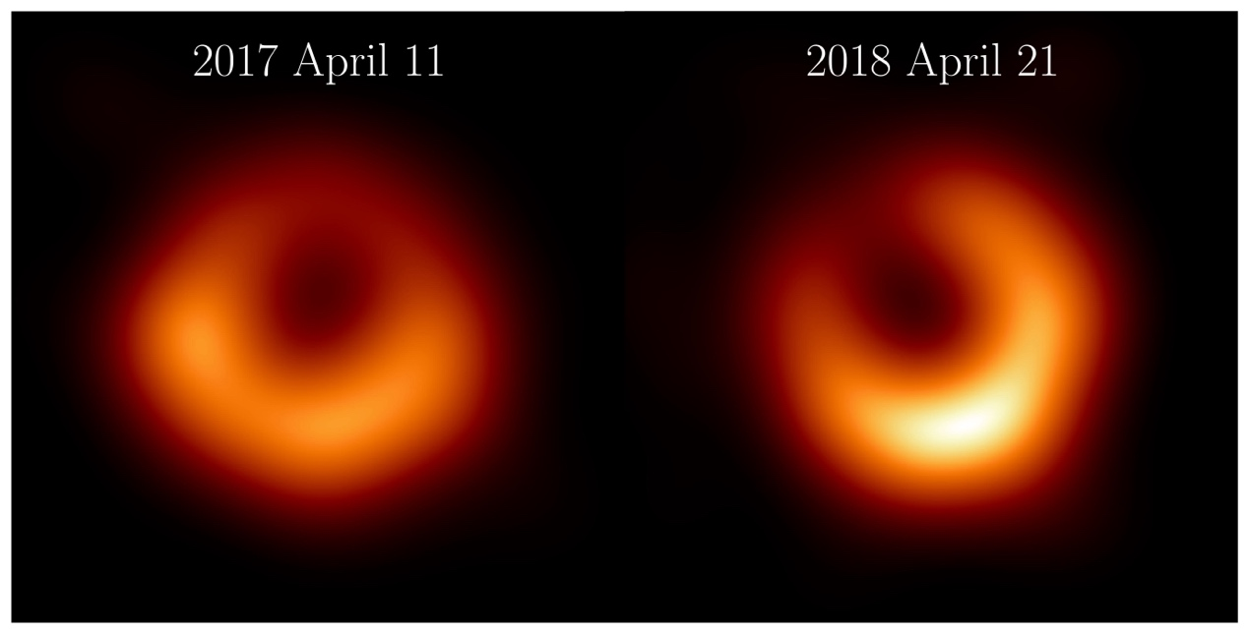
The Event Horizon Telescope Collaboration has released new images of M87* from observations taken in April 2018, one year after the first observations were taken. The new images, featuring the first participation of the Greenland Telescope in the EHT Collaboration, reveal a familiar, bright ring of emission of the same size as we found in 2017. This bright ring surrounds a dark central shadow, and the brightest part of the ring in 2018 has shifted by about 30º counter clockwise relative to its position in 2017.
Credit: Event Horizon Telescope Collaboration.

The Event Horizon Telescope (EHT) Collaboration, which includes researchers at Academia Sinica Institute for Astronomy and Astrophysics (ASIAA), National Taiwan Normal University (NTNU) and National Sun Yat-san University (NSYSU) in Taiwan, has released new images of M87*, the supermassive black hole at the center of the galaxy Messier 87, using data from observations taken in April 2018. Using the newly commissioned Greenland Telescope with a highly improved recording rate, the 2018 observations gave us a view of an astronomical source independent of the first observations in 2017. A recent paper published in the journal Astronomy & Astrophysics presents new images from the 2018 data that reveal a familiar ring the same size as observed in 2017. This bright ring surrounds a deep central depression, “the shadow of the black hole,” as predicted by general relativity. Excitingly, the peak brightness of the ring has shifted by about 30º counter clockwise compared to its position in 2017, which is consistent with our theoretical understanding of the variability of the turbulent material around black holes.

Why observe M87* again?

“A fundamental requirement of science is to be able to reproduce results,” says Dr. Keiichi Asada, an Associate Research Fellow at ASIAA. “Confirmation of the ring in a completely new data set is a huge milestone for our collaboration and a strong indication that we are looking at a black hole shadow and the material orbiting around it.”

In 2017, the EHT took the first image of a black hole. This object, M87*, is the beating heart of the giant elliptical galaxy Messier 87 and lives 55 million light years from Earth. The image of the black hole revealed a bright circular ring, brighter in the southern part of the ring. Further analysis of the data using polarized light revealed more of the structure of M87*, giving us greater insight into the geometry of the magnetic field and the nature of the plasma around the black hole.

The new era of black hole direct imaging, spearheaded by the extensive analysis of the 2017 observations of M87*, opened a new window that let us investigate black hole astrophysics and allow us to test the theory of general relativity at a fundamental level. Our theoretical models tell us that the state of the material around M87* should be uncorrelated between 2017 and 2018. Therefore, according to NTNU Assistant Professor and Ministry of Education Yushan Young Scholar Dr. Hung-Yi Pu, multiple observations of M87* will help us place independent constraints on the plasma and magnetic field structure around the black hole and help us disentangle the complicated astrophysics from the effects of general relativity.

To help advance this new and exciting science, the EHT is under continuous development. In 2018, the EHT was joined by the Greenland Telescope, which was constructed just five months ago inside the Arctic Circle. Led by a Taiwanese group and established as an international collaboration project, the Greenland Telescope was officially launched in 2010. Participation in the EHT observations marked the outcome of long-term endeavors. The Greenland Telescope significantly improved the image fidelity of the EHT array and increased the coverage, particularly in the North-South direction. The Large Millimeter Telescope also participated for the first time with its full 50 meter surface, greatly improving its sensitivity. The EHT array was also upgraded, allowing observations in four frequency bands around 230 GHz, compared to only two bands in 2017.

“[The] Greenland Telescope is located well inside the Arctic Circle, 76º North, where no other radio telescope exists. EHT observations with this northernmost telescope in the world allow us to obtain far more detailed information toward the North-South direction.” says Dr. Satoki Matsushita, a Research Fellow at ASIAA and the primary investigator of the Greenland Telescope project. “With our telescope joined in the EHT observations, the quality of the black hole shadow images greatly improved, and significantly contributed to these results.”

Repeated observations with an improved array are essential to demonstrate the robustness of our findings and strengthen our confidence in the results. In addition to the groundbreaking science, the EHT also serves as a technology test bed for cutting-edge developments in high-frequency radio interferometry.

“Advancing scientific endeavors requires continuous enhancement in data quality and analysis techniques,” said Rohan Dahale, a PhD candidate at the Instituto de Astrofísica de Andalucía in Spain. "The inclusion of the Greenland Telescope in our array filled critical gaps in our earth-sized telescope. The 2021, 2022, and the forthcoming 2024 observations witness improvements to the array, fueling our enthusiasm to push the frontiers of black hole astrophysics."

What is the outcome of this work?

The analysis of the 2018 data features eight independent imaging and modeling techniques, including methods used in the previous 2017 analysis of M87* and new ones developed from the collaboration’s experience analyzing Sgr A*.

The image of M87* taken in 2018 is similar to what we saw in 2017. We see a bright ring of the same size, with a dark central region and one side of the ring brighter than the other. The mass and distance of M87* will not appreciably increase throughout our lifetimes, so general relativity predicts that the ring diameter should stay the same from year to year. The stability of the measured diameter in the images from 2017 to 2018 supports the conclusion that M87* is well described by general relativity.

“One of the remarkable properties of a black hole is that its radius is strongly dependent on only one quantity: its mass,” said Dr. Nitika Yadlapalli Yurk, a former graduate student at the California Institute of Technology (Caltech), now a Postdoctoral Fellow at the Jet Propulsion Laboratory in California. “Since M87* is not accreting material (which would increase its mass) at a rapid rate, general relativity tells us that its radius will remain fairly unchanged over human history. It’s pretty exciting to see that our data confirm this prediction.”

While the size of the black hole shadow did not change between 2017 and 2018, the location of the brightest region around the ring did change significantly. The bright region rotated about 30º counterclockwise to settle in the bottom right part of the ring at about the 5 o’clock position. Historical observations of M87* with a less sensitive array and fewer telescopes also indicated that the shadow structure changes yearly but with less precision (Wielgus 2020, ApJ, 901, 67). While the 2018 EHT array still cannot reveal the jet emerging from M87*, the black hole spin axis predicted from the location of the brightest region around the ring is more consistent with the jet axis seen at other wavelengths.

“The biggest change, that the brightness peak shifted around the ring, is actually something we predicted when we published the first results in 2019,” said Dr. Britt Jeter, a Postdoctoral Fellow at ASIAA. “While general relativity says the ring size should stay pretty fixed, the emission from the turbulent, messy accretion disk around the black hole will cause the brightest part of the ring to wobble around a common center. The amount of wobble we see over time is something we can use to test our theories for the magnetic field and plasma environment around the black hole.”

In order to accomplish the results, more than 300 people around the globe worked in collaboration towards the same goal. "A single paper summarized all the technical and scientific work. Even the most unsung steps cannot be omitted. Each member contributed resources and personal expertise harmoniously, thus playing a part to solve this scientific puzzle," notes Dr. Cristina Romero-Cañizales, a Postdoctoral Fellow at ASIAA, emphasizing the importance of international collaboration.

Dr. Cheng-Yu Kuo, Associate Professor at NSYSU, encourages participation from younger generations. “GLT is beginning to play a major role for revealing further secrets of M87* in all aspects, from large-scale to horizon-scales. There are still many exciting new sciences and challenges waiting for us in the future. We encourage more talented Taiwanese students to join our team and make extraordinary contributions to our understanding of black holes.”

Future prospects

“This paper is the beginning of our unique contributions to fundamental science research. Ultimately, GLT will be used in future observations at higher frequencies, leading the revelation of the elusive photon ring within the black hole shadow image, making groundbreaking achievement in our understanding of black hole astrophysics.” concluded Dr. Ming-Tang Cheng, project manager of Greenland Telescope Project and Research Fellow at ASIAA regarding our future prospects.

While all the EHT papers published so far have featured an analysis of our first observations in 2017, this result represents the first efforts to explore the additional years of data we’ve collected. In addition to 2017 and 2018, the EHT has conducted successful observations in 2021 and 2022 and is scheduled to observe in the first half of 2024. Each year, the EHT array has been improved, through additions of new telescopes, enhanced hardware, or more observation frequencies. The collaboration team is currently working to analyze all the data and is excited about publishing more results in the future.

More Information:
The EHT collaboration involves more than 300 researchers from Africa, Asia, Europe, and North and South America. The international collaboration is working to capture the most detailed black hole images ever obtained by creating a virtual Earth-sized telescope. Supported by international investment, the EHT links existing telescopes using novel systems, creating a fundamentally new instrument with the highest angular resolving power to date.

The individual telescopes involved are the ALMA, the APEX, the Greenland Telescope (GLT), the IRAM 30-meter Telescope, the IRAM NOEMA Observatory, the James Clerk Maxwell Telescope (JCMT), the Kitt Peak Telescope, the Large Millimeter Telescope (LMT), the South Pole Telescope (SPT), the Submillimeter Array (SMA), and the Submillimeter Telescope (SMT). Data were correlated at the Max-Planck-Institut für Radioastronomie (MPIfR) and MIT Haystack Observatory. The postprocessing was done by an international team at different institutions.

The EHT consortium consists of 13 stakeholder institutes: the Academia Sinica Institute of Astronomy and Astrophysics, the University of Arizona, the University of Chicago, the East Asian Observatory, Goethe-Universitaet Frankfurt, Institut de Radioastronomie Millimétrique, Large Millimeter Telescope, Max Planck Institute for Radio Astronomy, MIT Haystack Observatory, National Astronomical Observatory of Japan, Perimeter Institute for Theoretical Physics, Radboud University, and the Smithsonian Astrophysical Observatory.

Article Information:
The Event Horizon Telescope Collaboration, The persistent shadow of the supermassive black hole of M87 I. Observations, calibration, imaging, and analysis, Astronomy & Astrophysics, January 18, 2024
doi: https://doi.org/10.1051/0004-6361/202347932

Contact Information:
● Mei-Yin Chou
Academia Sinica Institute of Astronomy and Astrophysics
Taipei, Taiwan
Tel: +886 (2) 2366-5415 (Office)
Email: cmy@asiaa.sinica.edu.tw
● Ming-Tang Chen
Academia Sinica Institute of Astronomy and Astrophysics
Taipei, Taiwan
Tel: +886 (2) 2366-5348 (Taiwan)
+1 (201) 808-961-2931 (Hilo)
Email: mtchen@asiaa.sinica.edu.tw
● Britt Jeter
Academia Sinica Institute of Astronomy and Astrophysics
Taipei, Taiwan
Tel: +886 (2) 3365-2200 (Front Office)
Email: bjeter@asiaa.sinica.edu.tw

