Academia Sinica Press Release

A Fluffy Disk Around a Baby Star

(Release time: Taiwan time August 23, 2013, 9:00 am)

A team led by Assistant Research Fellow Dr. Michihiro Takami, Institute of Astronomy and Astrophysics, Academia Sinica, unprecedentedly found a layer of dust almost transparent in the near infrared in the protoplanetary disk around RY Tau star which functions as a special baby duvet for forming planets. This finding, achieved by comparing observations and simulations, has brought significant insights to planet evolution theories. The paper was published in The Astrophysical Journal on Aug 1, 2013.

Planet formation, an exciting and active area for astronomical research, has long fascinated many scientists. Disks of dust and gas that rotate around young stars are of particular interest, because astronomers think that these are the sites where planets form--in these so-called “protoplanetary disks”. Since young stars and disks are born in molecular clouds, giant clouds of dust and gas, the role of dust becomes an important feature of understanding planet formation; it relates not only to the formation of rocky, Earth-like planets and the cores of giant Jupiter-like planets but also to that of moons, planetary rings, comets, and asteroids.

Subaru Telescope, one of the largest optical-IR telescopes in the world, located at Mauna Kea, Hawaii, has been in the forefront of developing instruments designed for planethunting and observing protoplanetary disks. The HiCIAO coronagraph, developed in 2009, combined with a new adaptive optics system, has produced an amazing ability to resolve the surface of protoplanetary disks. A research team is currently using this instrument to perform a large survey of exoplanets and disks (the Strategic Explorations of Exoplanets and Disks with Subaru Project, SEEDS).

As a part of the SEEDS project, researchers including Drs. Hiro Takami, Jennifer L. Karr, Hyosun Kim and Mei-Yin Chou (ASIAA) observed a possible planet-forming disk around the young star RY Tauri. This star is about 460 light years away from Earth in the constellation Taurus and is around half a million years old.

This team succeeded in capturing a near-infrared image (1.65 μm) associated with the RY Tauri disk. Unlike many other protoplanetary disks, the disk emission is offset from the center of the star (Figure 1, left). In contrast to longer wavelength observations, which are associated with the mid-plane of the disk, near-infrared, scattered light coming from the surface of the disk produced this offset (Figure 1, right), which provides information about the vertical structure of the disk.

Changes in structure perpendicular to the surface of a disk are much harder to investigate because there are few good examples to study. Therefore, the information about vertical structure that this image provides is a contribution to understanding the formation of planets, which depends strongly on the structure of the disk, including structures such as spirals and rings, as well as height.

The team performed extensive computer simulations of the scattered light, for disks with different masses, shapes, and types of dust. They found that the scattered light is probably not associated with the main surface of the disk, which is the usual explanation for the scattered light image (Figure 2a). Instead, the observed infrared emission can be explained if the emission is associated with a fluffy upper layer, which is almost transparent and not completely transparent (Figure 2b, Figure 3).

Why is this fluffy layer observed in this disk, but not in many other possible planet-forming disks? The team suspects that this layer is a remnant of the dust that fell onto the star and the disk during earlier stages of formation. In most stars, unlike RY Tau, this layer dissipates by this stage in the formation of the star, but RY Tau may still have it because of its youth. It may act as a special blanket to warm the inside of the disk for baby planets being born inside. This may affect the number, size, and composition of the planets being born in this system. The team therefore suspects that this may be one of the key features for understanding how a variety of exoplanetary systems exist.

The full Article:
http://iopscience.iop.org/0004-637X/772/2/145/pdf/0004-637X_772_2_145.pdf

Media Contact:
Dr. Takami, Michihiro, Assistant Research Fellow, Institute of Astronomy and Astrophysics, Academia Sinica, hiro@asiaa.sinica.edu.tw (Tel) +886-2-2366-5402
Dr. Gu, Pin-Gao, Associate Research Fellow, Institute of Astronomy and Astrophysics, Academia Sinica, gu@asiaa.sinica.edu.tw (Tel) +886-2-2366-5397
Ms. Pearl Huang, Office of the Director General, Central Office of Administration,
Academia Sinica pearlhuang@gate.sinica.edu.tw
(Tel) +886-2-2789-8820 (Fax) +886-2-2782-1551 (M) 0912-831-188
Ms. Mei-Hui Lin, Office of the Director General, Central Office of Administration,
Academia Sinica mhlin313@gate.sinica.edu.tw
(Tel) +886-2-2789-8821 (Fax) +886-2-2782-1551 (M) 0921-845-234

N
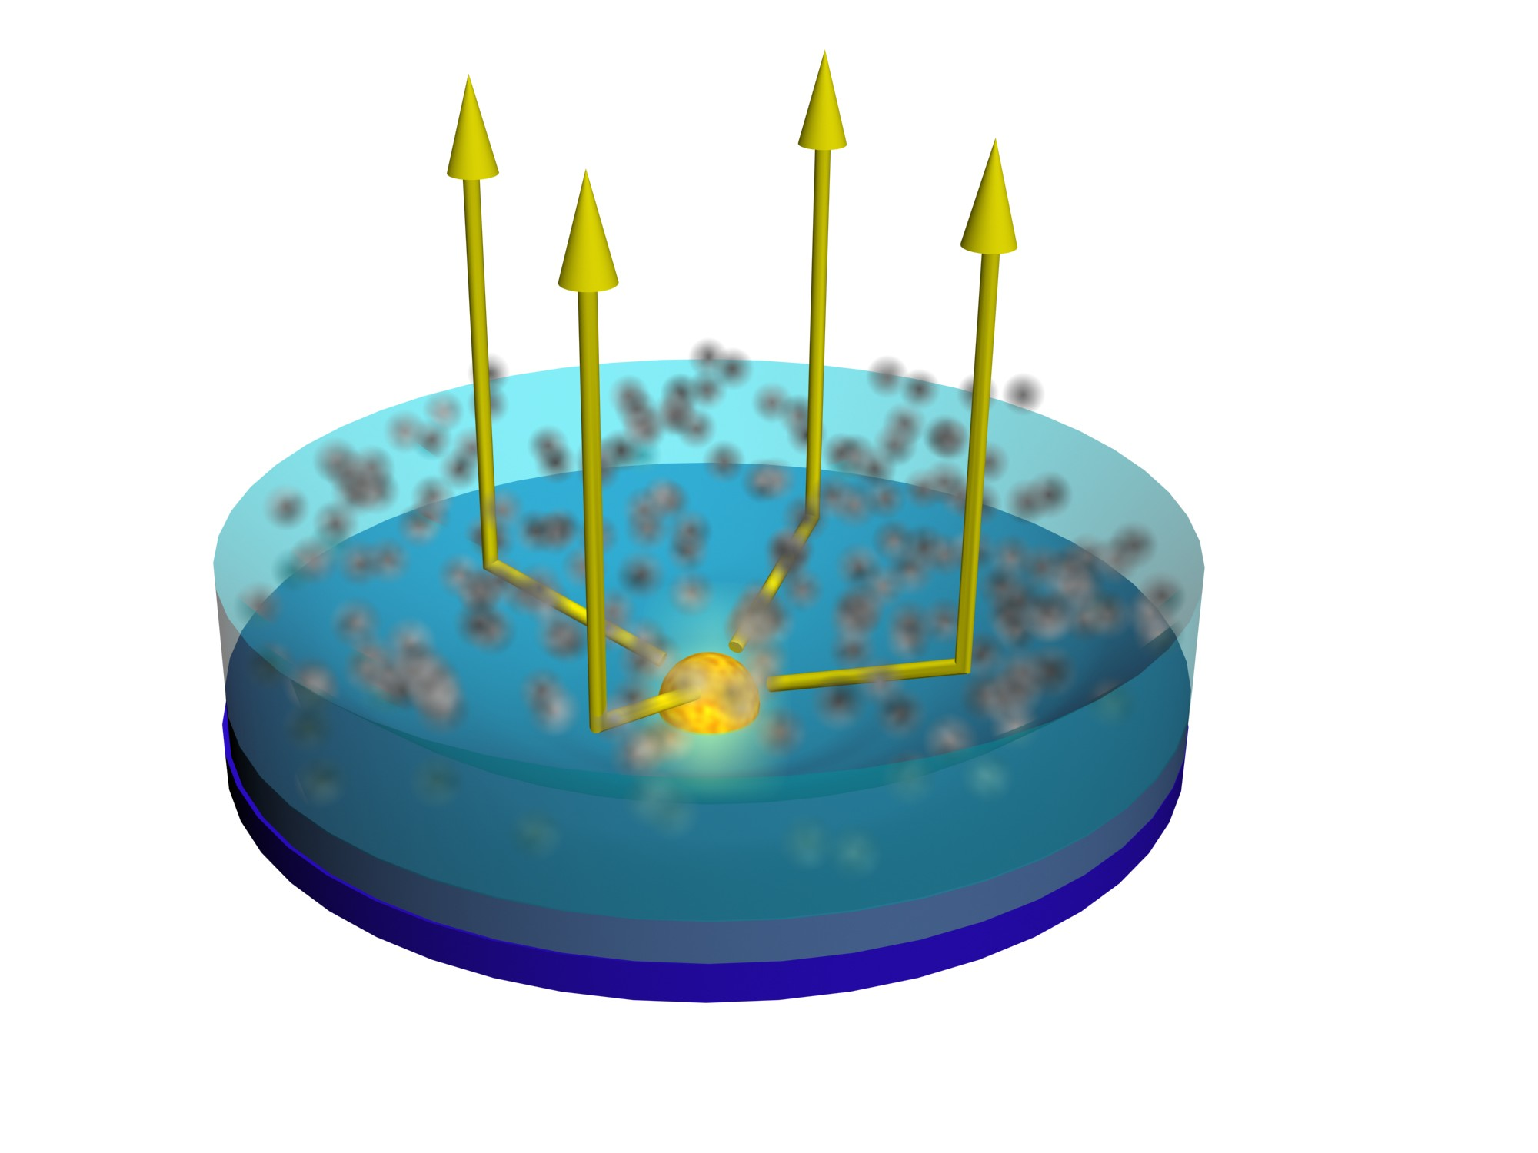
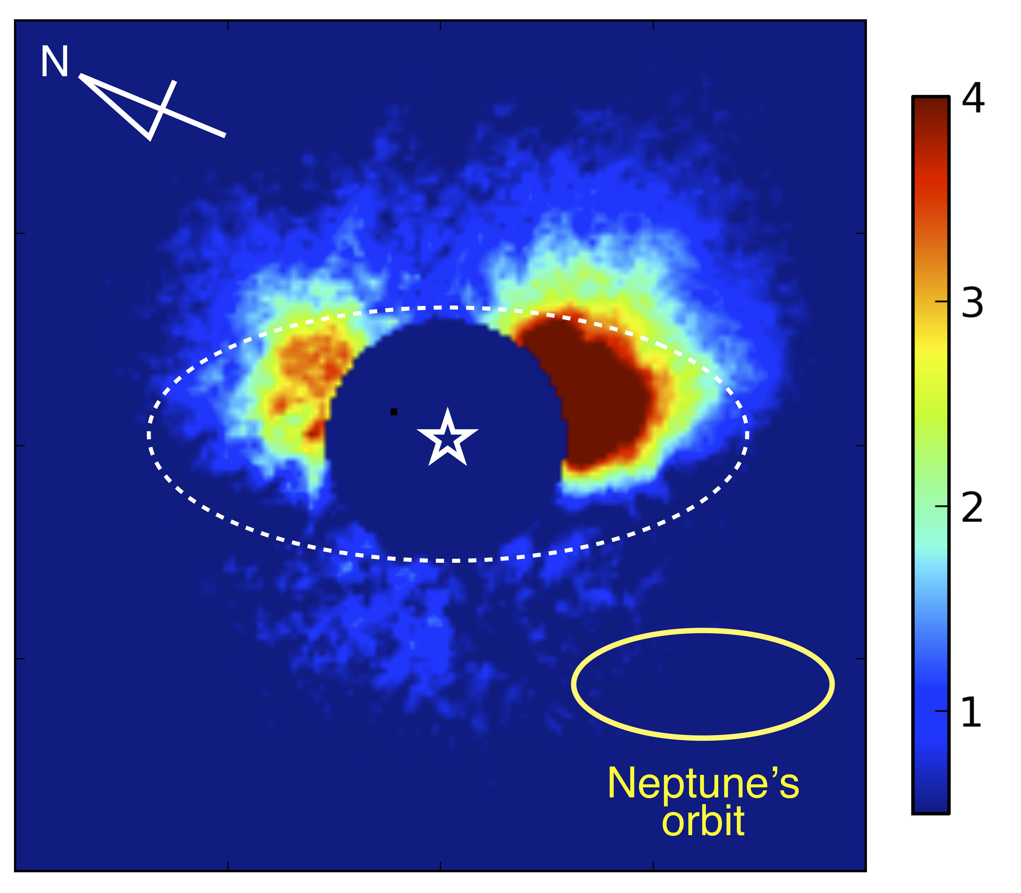
observed infrared light

star

upper dust layer

disk

Figure 1: (left) An image in the near infrared (1.65 µm) around RY Tau, using a special mode of the HiCIAO coronagraph, the polarized intensity image. This type of observation
is preferred for faint emissions associated with scattered light around planet-forming disks, as there is less light from the much brighter star. The colors indicate the strength of the emission (blue, yellow and red from faint to bright). A coronagraphic mask in the telescope optics blocks the central star, with its position marked at the center. A white ellipse shows the position of the midplane of the disk, which is observed at millimeter wavelengths. Scattered light observed in the near infrared is offset to the top of the image compared
with the denser millimeter disk.
(right) Schematic view of the observed infrared light. The light from the star is scattered in the upper dust layer, and it makes the observed light offset from the midplane.

(a)
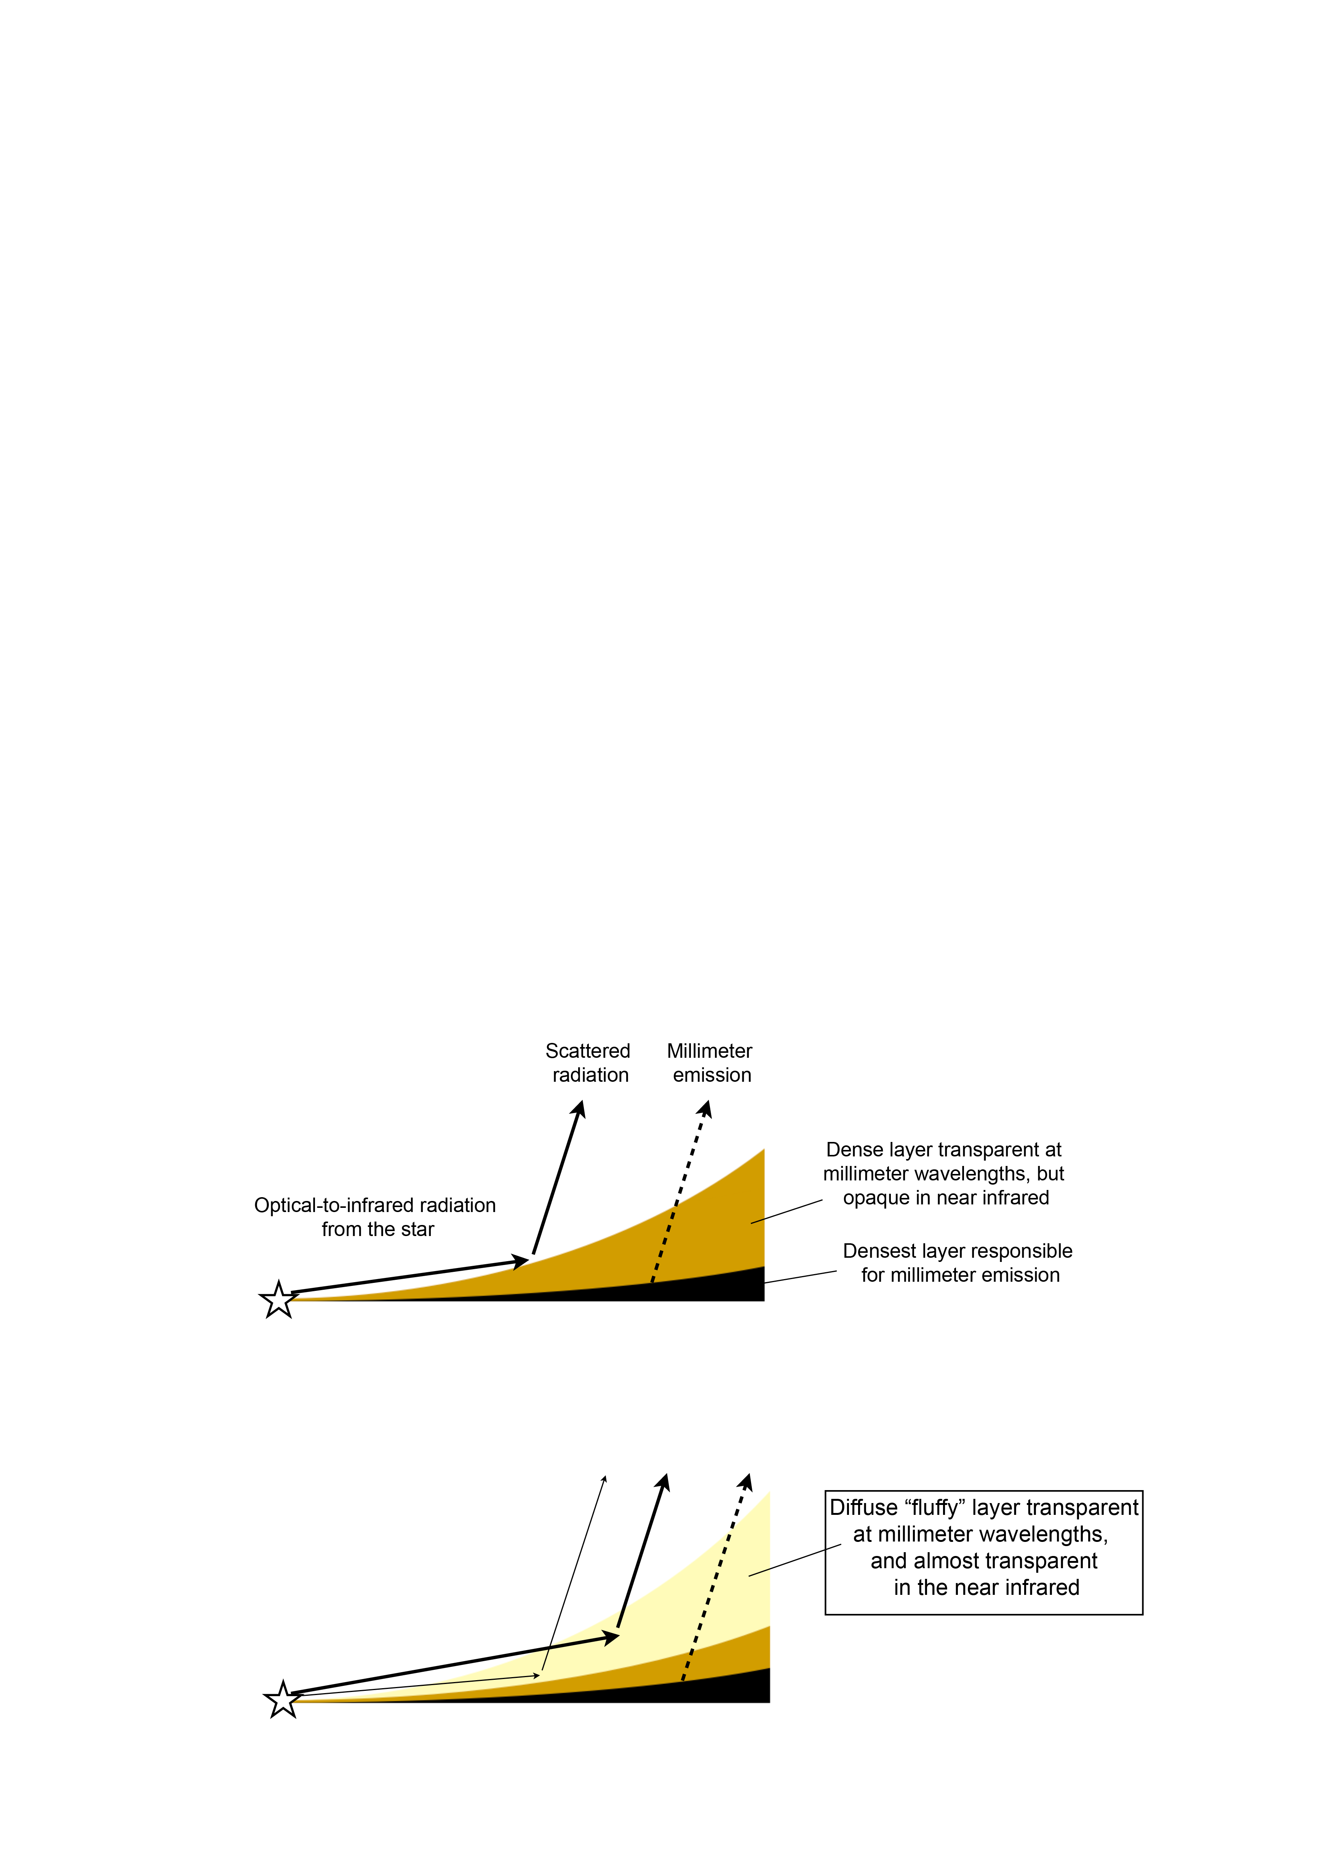

(b)
Millimeter emission
Scattered radiation
Optical-to-infrared radiation from the star

Figure 2: Schematic views of the structure of the protoplanetary disk. The disk is transparent at millimeter wavelengths, and as a result, the observed millimeter emission is associated with the densest region (the midplane). In contrast, the disk is opaque in the infrared in even at the upper layer. Researchers often assume that the near-infrared emission is due to scattered light from its surface like figure (a). Figure (b) shows the revised schematic view through this study for
RY Tau. There is another layer above the two layers in (a). This layer is almost transparent in the near infrared, but not completely. The team concludes that the scattered emission observed using Subaru-HiCIAO is mainly due to scattering in this layer.

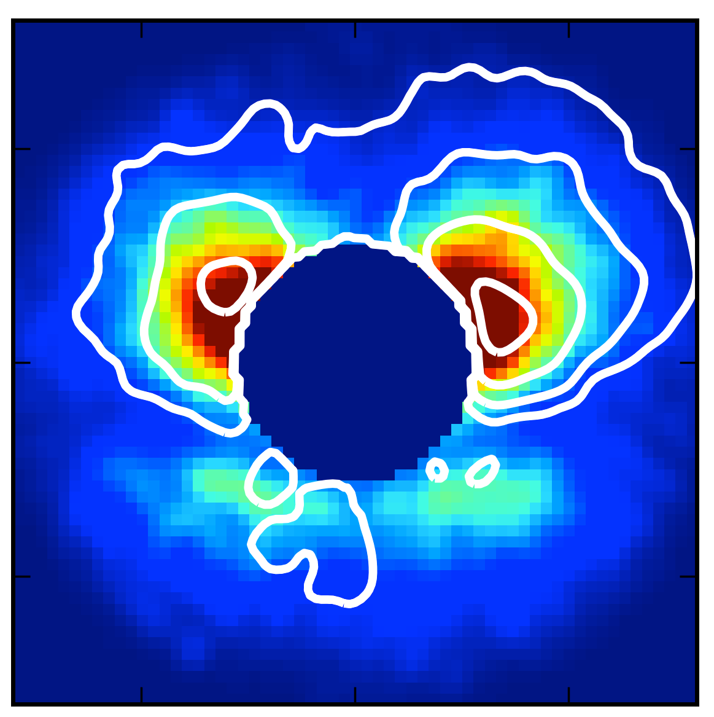
Figure 3: Computer simulation for dust scattering for RY Tau. The color indicates the strength of the modeled flux (blue, yellow and red for faint to bright). The white contours show the image observed using Subaru-HiCIAO. This modelled disk has a disk with a fluffy layer, and closely matches the image in shape and brightness.

